**CENWP-OD-B 13 August 2024**

**MEMORANDUM FOR THE RECORD**

**SUBJECT: 24BON044 MFR AFF Valve 15 Pacific Lamprey Mortality**

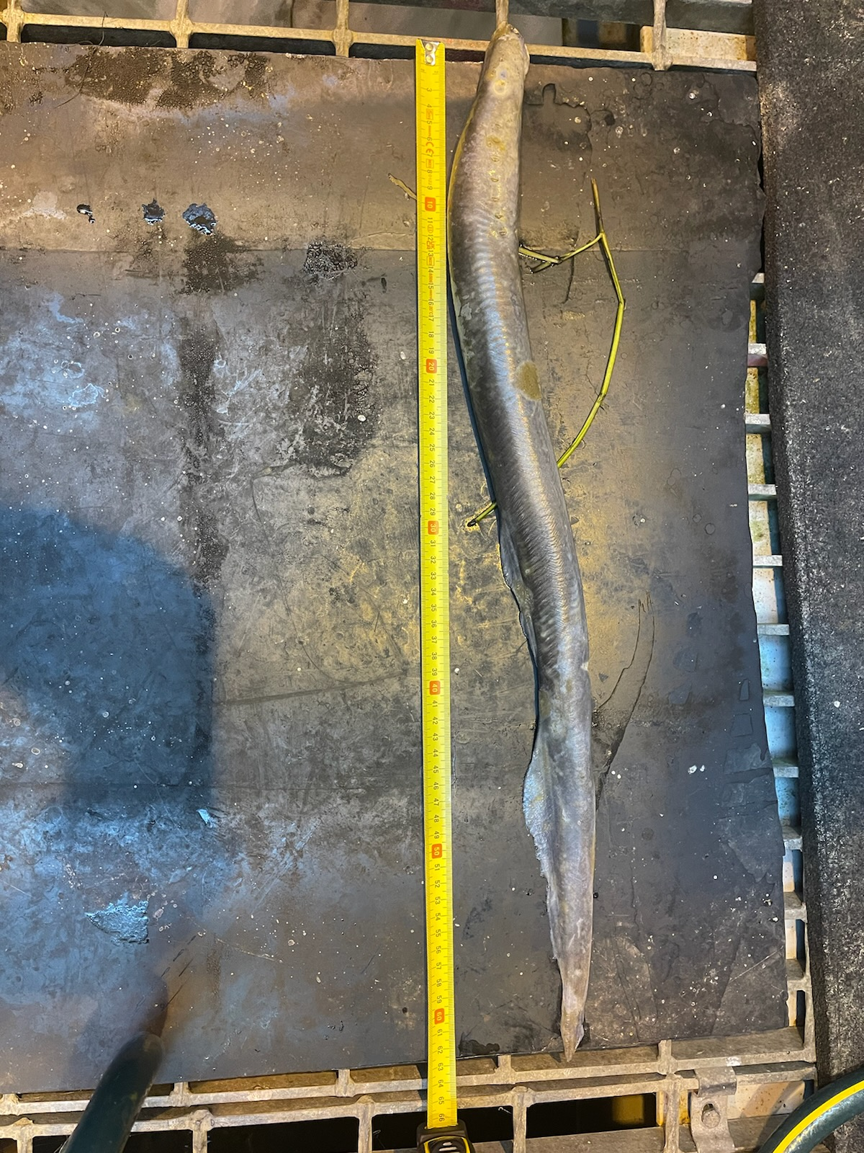On the morning of 13 August 2024, CRITFC Biologists notified Project Biologists of one adult Pacific Lamprey mortality discovered on the Adult Fish Facility’s valve 15 trash rack. The fish was measured, scanned for PIT tags, inspected, and returned to the river.

1. Species – Pacific Lamprey (*Entosphenus tridentatus*)
2. Origin – Unknown
3. Length – 63.0 cm
4. Marks and tags – None
5. Marks and Injuries found on carcass – Parasitic fungus present
6. Cause and Time of Death – Unknown
7. Future and Preventative Measures – N/A

Sincerely,

Bonneville Project Fisheries